Sean M. Reed, PhD, APRN, ACNS-BC, ACHPN, FCNS 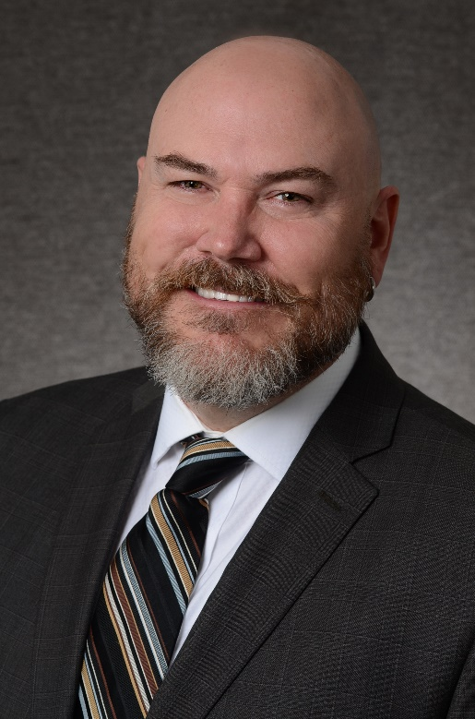

Sean M. Reed, PhD, APRN, ACNS-BC, ACHPN, is a Clinical Nurse Specialist in Adult Health and Hospice and Palliative Care. He has over 17 years experience in acute, post-acute, ambulatory, systems, and academic settings. Dr. Reed has an extensive background with the integration of expert clinical practice, consultation, leadership, research and implementation of evidence-based practices, and education. He is known as a pioneer in developing palliative care programs for the largest health care system in Colorado and was awarded the Pathfinder Award for his innovation in developing APRN models of care. He is currently an Assistant Professor at the University of Colorado, College of Nursing where he teaches and advises in the PhD Caring Science Track. Dr. Reed’s research focus is palliative care and high value-based care delivery.

