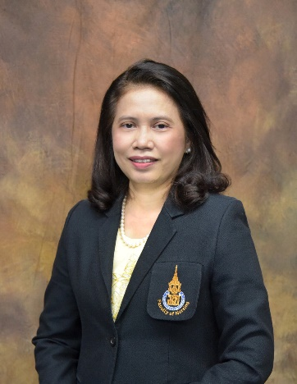
Biography
Waraporn Kongsuwan, RN.; Ph.D. is an Associate Professor of Nursing, Faculty of Nursing, Prince of Songkla University, Thailand. She was the first International student to complete her Ph.D. in Nursing program at Christine E. Lynn College of Nursing, Florida Atlantic University, USA. She authored the article "Development of the Emergent Theory of Aesthetic Nursing Practice (AesNURP)" in the year 2020.

